Ex. 6 P. 8

1. Today I’d like to give you an overview of our present market position.
2. I’ll be showing you how the database works.
3. During the next two hours we’ll be looking at business opportunities in Asia.
4. I’d like to bring to you up to date on SEKO’s investment plans.
5. This afternoon I’m going report on our financial targets for the division.
6. Today I’d like to update you on the proposed training project.
7. This morning we’ll be talking about EU tax reform.
8. Today I’ll begin by telling you about what Jane’s group is working on.

Ex. 7 P. 9

1. Start
2. Then
3. Finally
4. Divided
5. All
6. After
7. Areas
8. Third

Ex. 7 P. 9

1. For
2. Into
3. Of
4. At
5. On
6. With
7. About
8. To

Ex. 9 P. 10

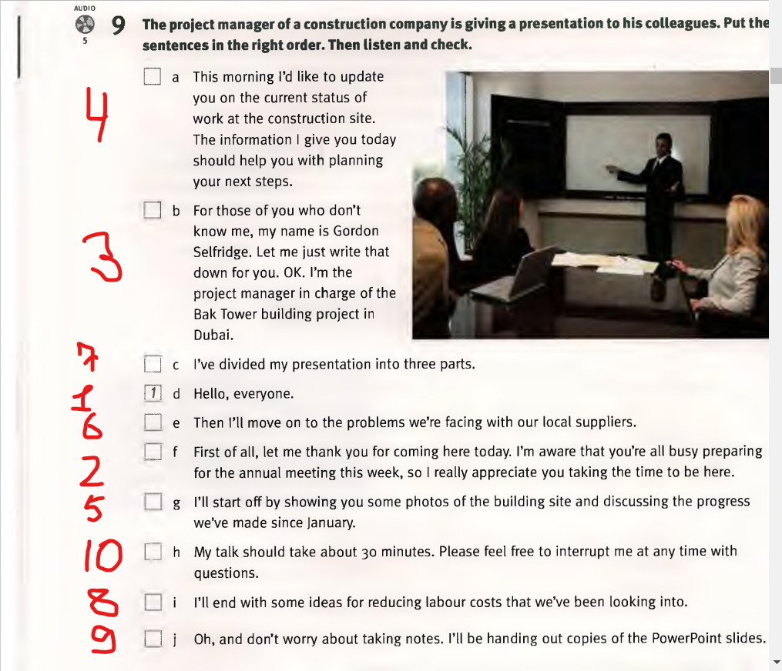

1. B
2. D
3. I
4. F
5. G
6. A
7. C
8. H
9. E

Ex. 10 P. 11

1. Begin
2. Sections
3. I’m
4. After that, turn
5. Responsible for

Ex. P. 6

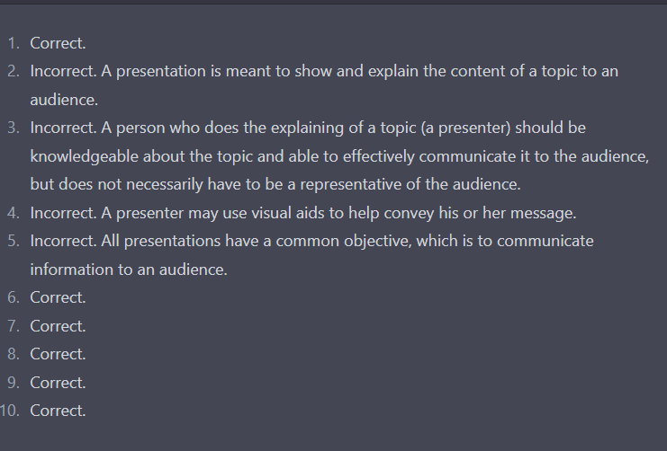

Ex. P. 7

1. Informative
2. Instructional
3. Persuasive
4. Arousing
5. Decision making

Ex. 10 P. 20

1. As you probably know, we **are** currently **dealing** with difficulties with our new men’s cosmetic line.
2. I’d like to quickly **identify** the problems and then make some suggestions on how we can **cope** with the consequences.
3. We’ve been trying to **deal** with these problems - the delays, the poor quality - all along, but so far we’ve not been able to find ways to **prevent** them from happening again.
4. It’s clear we can no longer continue to **accept** these conditions.
5. If we **don't solve** our supply problems within the next two weeks, we **will run** into serious trouble with respect to our Christmas business.

Ex. 11 P. 21

1. How are we going to **deal** with delivery problems?
2. I don’t think we can **cope** with fewer people.
3. We think it’s important to **identify** the problems now.
4. Who will **take care** of our business clients?
5. We have been trying to **solve** the software problem.
6. Before we go on, let’s **clarify** this question.

Ex. 12 P. 21

1. I’ll give you an overview of some figures **regarding** car exports.
2. **Moreover**, I’d like to tell you something about the new software.
3. Let’s now turn to the next question which **concerns** customer service.
4. **Apart from** a few spelling mistakes, the new brochure is very good.
5. Let me give you some details **with** **regard** to our Chinese factory.
6. **Regarding** the handbook, the scanner is user-friendly.

Ex. 13 P. 21

1. Let's move on to the next point now.
2. As you know, today's topic is globalization.
3. My aim is to inform you about the latest developments.
4. We will additionally be discussing the most important figures.
5. As I said earlier, I'll give you a brief overview.
6. According to this study, our customers are satisfied with it.

Ex. 1 P. 23

1. Whiteboard
2. PowerPoint slide
3. Flip chart

Ex. 2 P. 24

1. These figures
2. Highlight, two quarters
3. Figures, board
4. Have a look
5. Next slide, illustration
6. Sales figures, first
7. Can see
8. Go back, page
9. Flip back

Ex.